Date: December 27, 2024

To: PCTNA Dealers

Subject: Technical Service Bulletin #1-Recall Remedy Process

With the voluntary recall announcement, we are providing you with a Technical Service Bulletin on how to properly remove the 3PMS Alpine Symbol from the Fortune Tormenta R/T FSR309, Prinx HiCountry R/T HR1, Fortune Tormenta M/T FSR310 and Prinx HiCountry M/T HM1 tire. Below is a step-by-step explanation of the process:

1. Locating the 3PMS Alpine Symbol
To locate the 3PMS Alpine symbol on the tire, check the sidewall and DOT markings, as the symbol is always positioned to the right of the DOT markings on both sides of the tire.
2. Remedy Process
The remedy process takes approximately 40 seconds to 1 minute to completely remove the 3PMS symbol from both sides of the tire. It involves using a buffer to gently smooth the surface of the tire where the symbol is located.
3. Before, During and After Images
We have included below, before, during and after images to help illustrate the results of buffing the symbol off the tire. As you can see, the symbol is fully removed, leaving a smooth, clean surface.
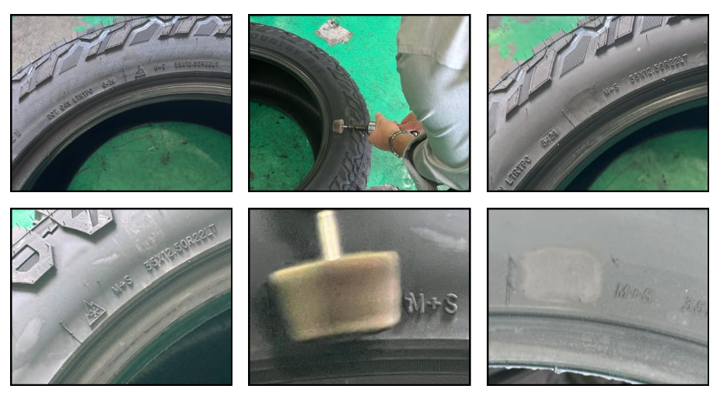
4. Remedied Tires
Once the 3PMS Alpine symbol has been buffed from each side, the tires are considered to have been remedied and are no longer part of the recall. These tires can now be sold. The removal of the 3PMS Alpine symbol will not affect the performance of these tires and are covered by our Fortune or Prinx Limited Passenger Car and Light Truck Tire Warranty for North America.
5. Tire Remedy Documentation
PCTNA is requesting each dealer to complete a form indicating the number of tires that have been remedied by SKU. Sample photos of the buffed tires will also need to be provided with the form. These forms are available from your sales representative. Once the completed forms are returned, PCTNA will issue credit to compensate for the remedy process. Please note that PCTNA reserves the right to arrange an independent verification of the tires claimed to have been remedied.
Best regards,
Ken Coltrane
Vice President, Marketing & Product Development

